Dear New PGCE Science Student

Thank-you for choosing us to support you on your journey to becoming a secondary school science teacher.

Congratulations on successfully navigating the application process and passing the interview!

You are now almost ready to begin the PGCE course in September 2024.

I am the science course leader –Simon Neville [simon.neville@bristol.ac.uk](mailto:simon.neville@bristol.ac.uk) (we probably met at interview!). My colleagues and I are really looking forward to meeting you in person and getting to know you. Learning how to be a teacher is an exciting prospect, but can also be a challenging time, so we are prepared and eager to guide you on this undertaking. We are subject and pedagogy lecturers, with many decades of classroom teaching experience and tutoring/mentoring expertise.

The expectation for you is to be able to teach biology, chemistry and physics at Key Stage 3 and 4 (11-16 year olds) and your own specialism to Key Stage 5 (16-19 year olds). To prepare for this you should start to read up about the subject content that this covers. We use the AQA 9-1 syllabus as a core syllabus, so this would be a good place to start. You can also download GCSE past papers, I would advise that trying at least one from each science would also be beneficial prior to starting the course.

[AQA | Subjects | Science | GCSE](https://www.aqa.org.uk/subjects/science/gcse?msclkid=410014b6b36411ecbc2c48d6314fadec) [www.aqa.org.uk](http://www.aqa.org.uk)

There are a few other areas that I recommend you get immersed in before your course begins, but they are not compulsory:

**Understanding current educational issues:**

Begin to familiarise yourself with some current educational issues. Newspapers are a good place to start - ‘education day’ is Tuesday in the *Guardian* and Thursday in the *Independent.* The main newspaper you should read on a regular basis isthe T.E.S. (Times Educational Supplement), published each Friday.

<https://www.tes.com/>

**Classroom teaching:**

There are many approaches to becoming an effective science teacher and we will look at these during the year but the following books are really helpful. I will not expect you to read them before the course starts and you do not need to buy them but if you do want to invest there are excellent charity book shops in Bristol (Amnesty and Barnardo’s on Gloucester Road, Bristol, and Oxfam at the top of Park Street, in Cotham, and in Clifton village). Online [www.abebooks.co.uk](http://www.abebooks.co.uk) is very good value for money too. There is always Amazon too!

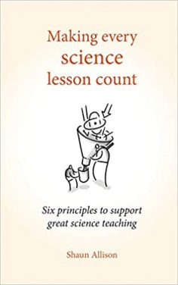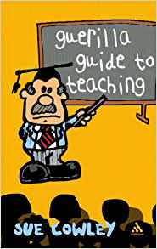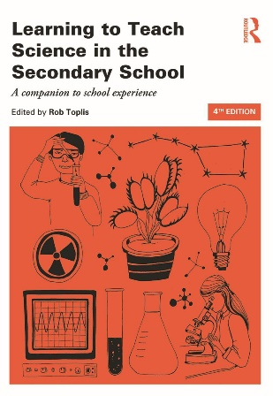

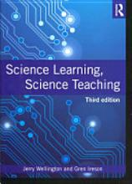

Wellington, J. and Ireson, G. (2012) *Science Learning, Science Teaching,* Abingdon: Routledge.

Allison, S. (2017) *Making Every Science Lesson Count: six principles to support great science teaching.* Crown House Publishing

Cowley, S. (2007) *Guerilla Guide to Teaching*. Bloomsbury Publishing plc.

Toplis, R. (2015) *Learning to Teach Science in the Secondary School*. Taylor and Francis. Routledge.

National Curriculum in England <https://www.gov.uk/government/collections/national-curriculum>

**Research based teaching and education:**

These are also some fantastic texts about the wider aspects of teaching and learning. You do not have to read these before the course starts but they will be useful in the longer run.

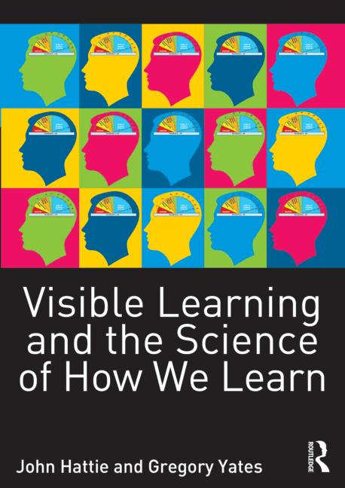 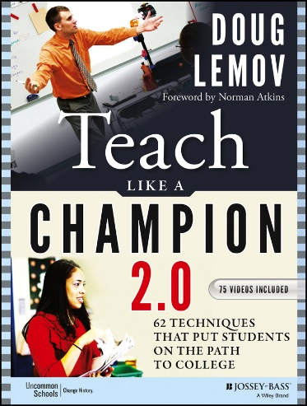 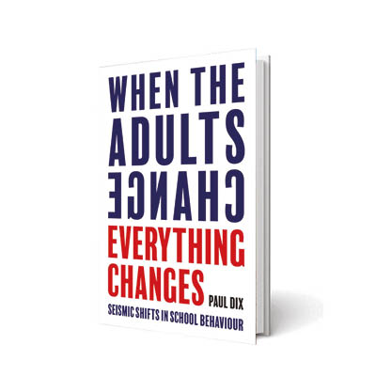

Hattie, J. and Yates, G. (2014) *Visible Learning and the Science of How We Learn*. Routledge.

Lemov, D. (2015) *Teach Like a Champion 2.0*. Jossey-Bass.

Dix, P. (2017) *When the Adults Change Everything Changes*. Independent Thinking Press.

**Finally, if you are interested in learning more about Bristol:**

<http://www.bristol.ac.uk/education/expertiseandresources/bristolguide/>

Please do not hesitate to contact me if you have any questions, and well done again! **Simon H Neville** [simon.neville@bristol.ac.uk](mailto:simon.neville@bristol.ac.uk)